class Solution {
public int maxSubArray(int[] nums) {
int currentSum = nums[0];
int maxSum = nums[0];

for (int i = 1; i < nums.length; i++) {
currentSum = Math.max(nums[i], currentSum + nums[i]);
maxSum = Math.max(maxSum, currentSum);
}

return maxSum;
}
}

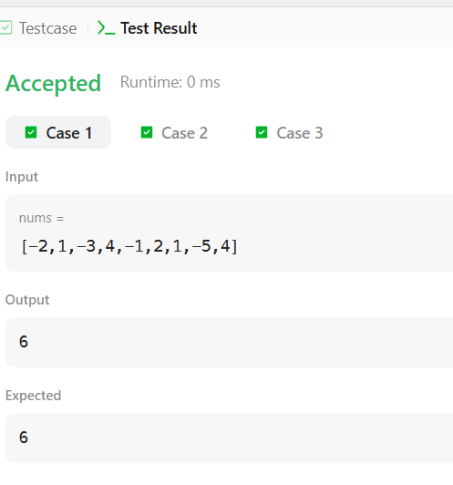
import java.io.*;
import java.util.*;

public class Solution {

public static int birthday(List<Integer> s, int d, int m) {

int count = 0;

for (int i = 0; i <= s.size() - m; i++) {

int sum = 0;

for (int j = i; j < i + m; j++) {
sum = sum + s.get(j);
}

if (sum == d) {
count++;
}
}

return count;
}

public static void main(String[] args) throws IOException {

BufferedReader br = new BufferedReader(
new InputStreamReader(System.in)
);

int n = Integer.parseInt(br.readLine().trim());

String[] values = br.readLine().trim().split(" ");

List<Integer> s = new ArrayList<>();

for (String value : values) {
s.add(Integer.parseInt(value));
}

String[] dm = br.readLine().trim().split(" ");

int d = Integer.parseInt(dm[0]);
int m = Integer.parseInt(dm[1]);

int result = birthday(s, d, m);

System.out.println(result);
}
}

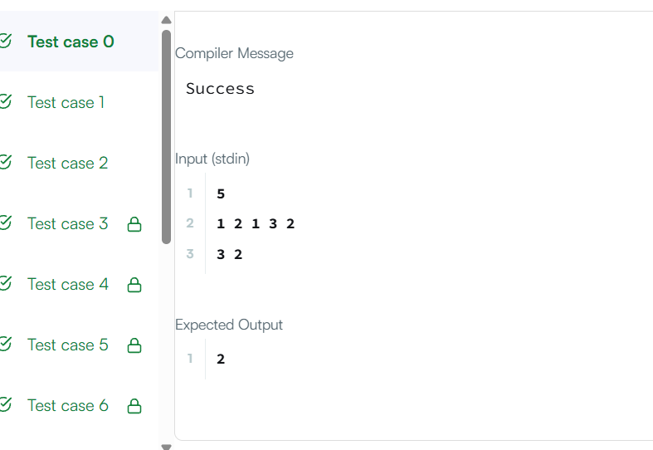

class Solution {
public int maxSubarraySumCircular(int[] nums) {

int total = 0;

int maxSum = nums[0];
int currentMax = 0;

int minSum = nums[0];
int currentMin = 0;

for (int num : nums) {

currentMax = Math.max(num, currentMax + num);
maxSum = Math.max(maxSum, currentMax);

currentMin = Math.min(num, currentMin + num);
minSum = Math.min(minSum, currentMin);

total += num;
}

// All numbers are negative
if (maxSum < 0) {
return maxSum;
}

// Maximum circular sum
int circularSum = total - minSum;

return Math.max(maxSum, circularSum);
}
}

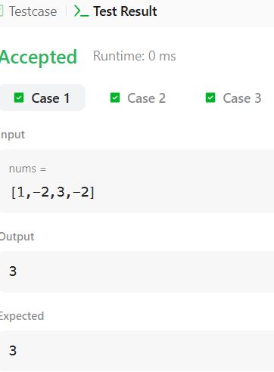

class Solution {
public int myAtoi(String s) {

int i = 0;
int n = s.length();

// Skip spaces
while (i < n && s.charAt(i) == ' ') {
i++;
}

// Check sign
int sign = 1;

if (i < n && s.charAt(i) == '-') {
sign = -1;
i++;
} else if (i < n && s.charAt(i) == '+') {
i++;
}

int result = 0;

// Convert digits
while (i < n && Character.isDigit(s.charAt(i))) {

int digit = s.charAt(i) - '0';

// Check overflow
if (result > (Integer.MAX_VALUE - digit) / 10) {
if (sign == 1) {
return Integer.MAX_VALUE;
} else {
return Integer.MIN_VALUE;
}
}

result = result * 10 + digit;
i++;
}

return result * sign;
}
}

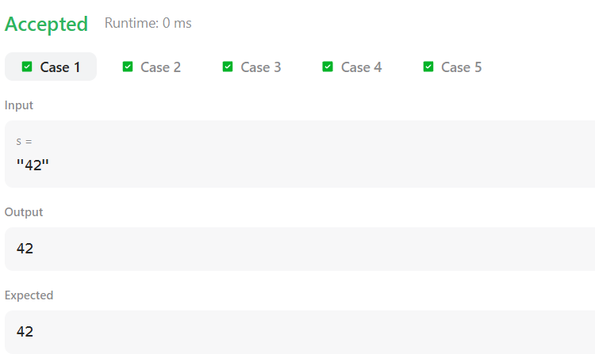

class Solution {
public int maxSubarraySumCircular(int[] nums) {

int total = 0;

int maxSum = nums[0];
int currentMax = 0;

int minSum = nums[0];
int currentMin = 0;

for (int num : nums) {

currentMax = Math.max(num, currentMax + num);
maxSum = Math.max(maxSum, currentMax);

currentMin = Math.min(num, currentMin + num);
minSum = Math.min(minSum, currentMin);

total += num;
}

// All numbers are negative
if (maxSum < 0) {
return maxSum;
}

// Maximum circular sum
int circularSum = total - minSum;

return Math.max(maxSum, circularSum);
}
}

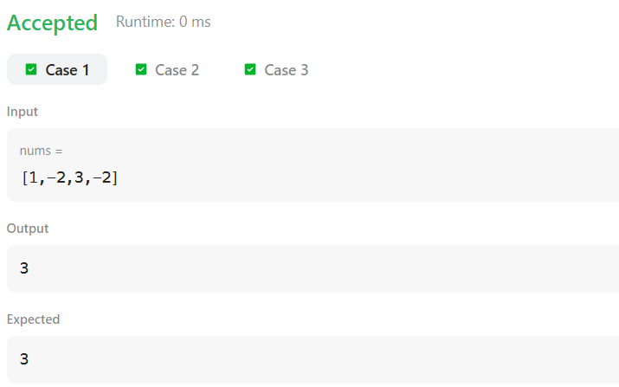

import java.io.*;
import java.util.*;

public class Solution {

public static int alternatingCharacters(String s) {

int count = 0;

for (int i = 1; i < s.length(); i++) {

if (s.charAt(i) == s.charAt(i - 1)) {
count++;
}
}

return count;
}

public static void main(String[] args) throws IOException {

BufferedReader br = new BufferedReader(
new InputStreamReader(System.in)
);

int q = Integer.parseInt(br.readLine().trim());

for (int i = 0; i < q; i++) {

String s = br.readLine();

System.out.println(alternatingCharacters(s));
}
}
}

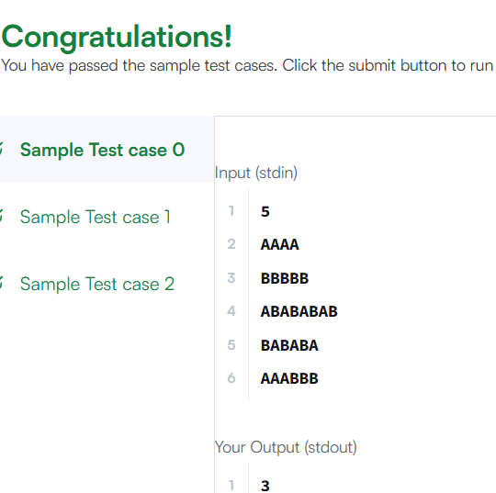

class Solution {
public int lengthOfLongestSubstring(String s) {

int max = 0;

for (int i = 0; i < s.length(); i++) {

String str = "";

for (int j = i; j < s.length(); j++) {

if (str.indexOf(s.charAt(j)) != -1) {
break;
}

str = str + s.charAt(j);
max = Math.max(max, str.length());
}
}

return max;
}
}

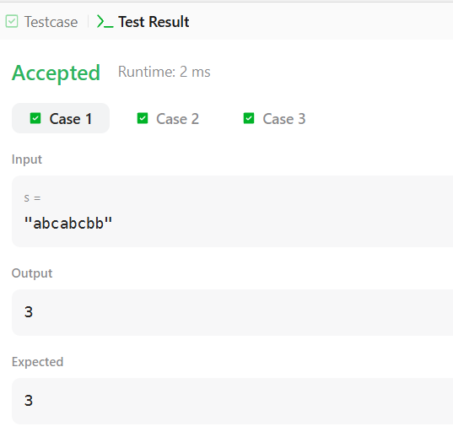

class Solution {

public List<String> findAndReplacePattern(String[] words, String pattern) {

List<String> result = new ArrayList<>();

for (String word : words) {

if (matches(word, pattern)) {
result.add(word);
}
}

return result;
}

public boolean matches(String word, String pattern) {

int[] map1 = new int[26];
int[] map2 = new int[26];

for (int i = 0; i < word.length(); i++) {

int w = word.charAt(i) - 'a';
int p = pattern.charAt(i) - 'a';

if (map1[w] != map2[p]) {
return false;
}

map1[w] = i + 1;
map2[p] = i + 1;
}

return true;
}
}

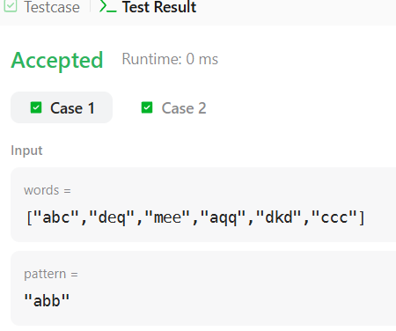

import java.util.*;

class Solution {
public List<String> stringMatching(String[] words) {

List<String> result = new ArrayList<>();

for (int i = 0; i < words.length; i++) {

for (int j = 0; j < words.length; j++) {

if (i != j && words[j].contains(words[i])) {
result.add(words[i]);
break;
}
}
}

return result;
}
}

